Offensive language detection

Problem description

Many people on social media sites use hate words and offensive language in their expression towards people or in general
our model designed to detect tweets with offensive language or hate words

Model design

- Dataset

dataset contains 24783 tweets(offensive, not offensive) with labels(1, 0)
split it into 19827 for train and 4956 for test.

- Preprocessing

we removed hyberlinks, twitter marks, hashtags and styles
we removed stop words and punctuations
we applied tokenization (split tweet to tokens)
we applied stemming (convert the word to general form)

- Training

we used naive bayes classifier and logistic regression classifier

- Testing

we testes the model after using two algorthims and get accuracies on test data

Expermental results

naive bayes
test accuracy : 0.956
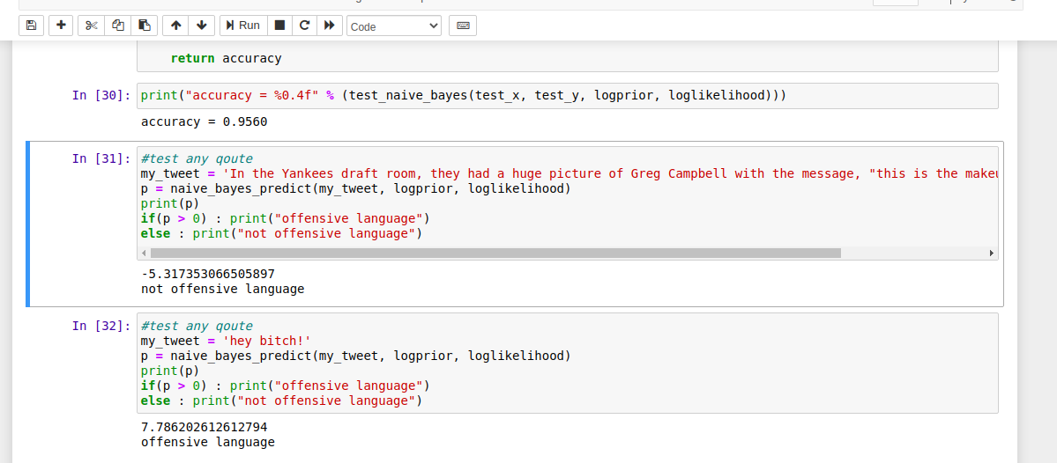

logistic regression
test accuracy : 0.839

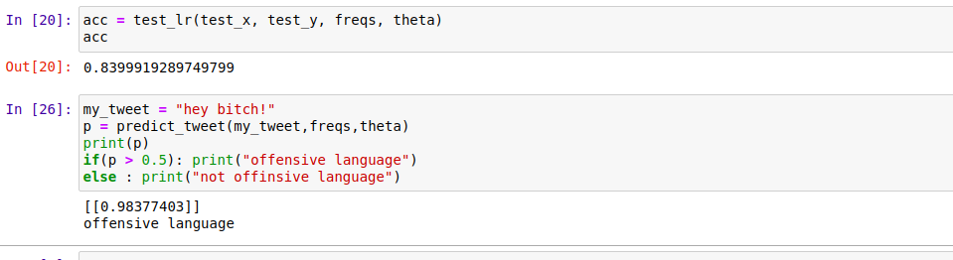
Model performance

we get the best accuracy with naive bayes classifier (0.956) it’s better than logistic regression

